Lab 2

Make a relationship between following tables (20%):

- Passengers with Secuitiry_check, Booking, Baggage_check by passenger_id;

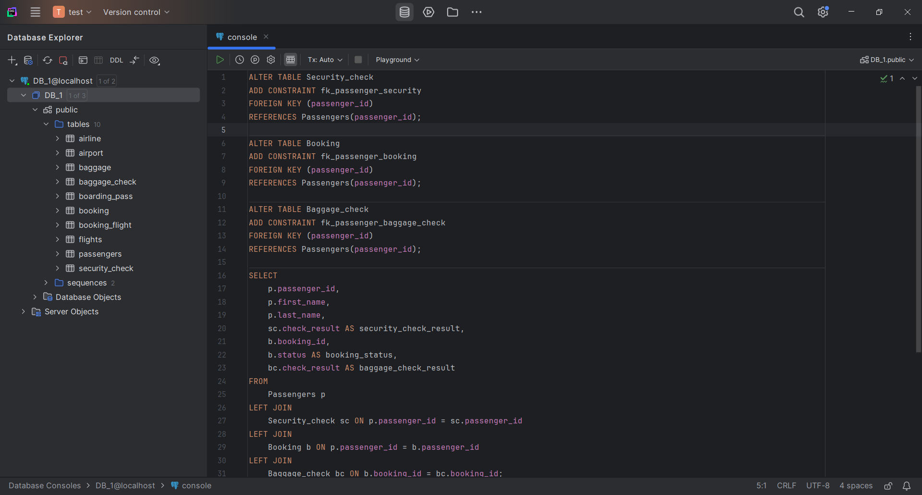

-Booking with Baggage_check, Baggage, Boarding_pass, Booking_flight by booking_id;

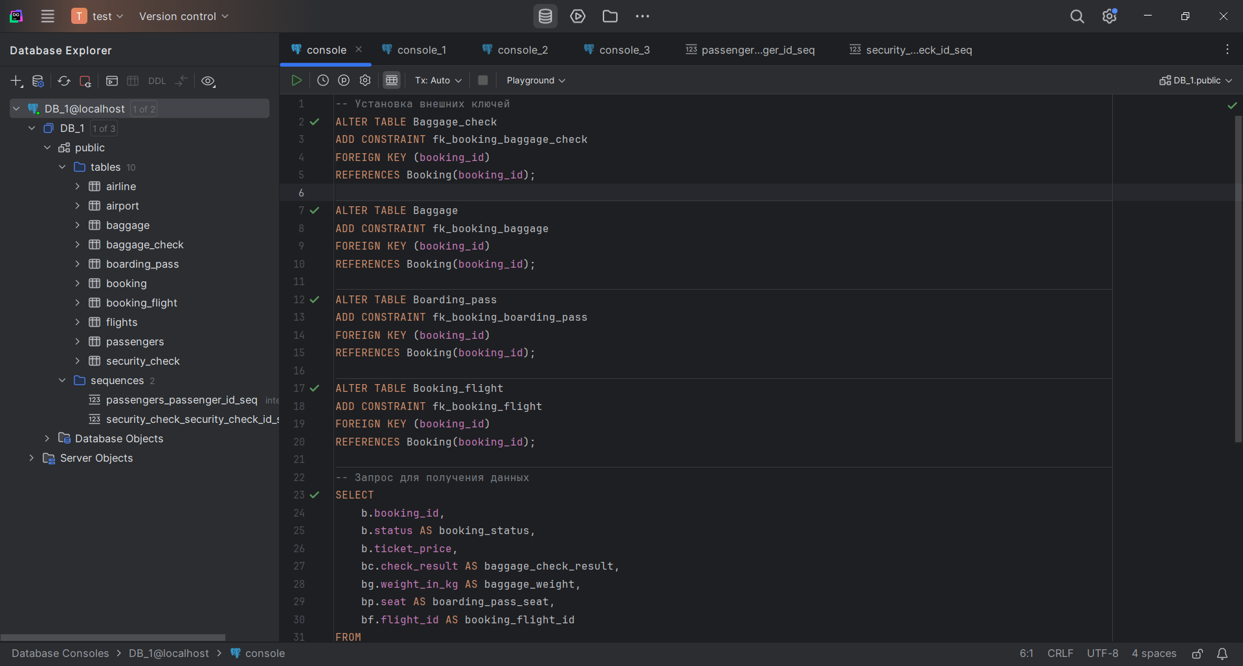

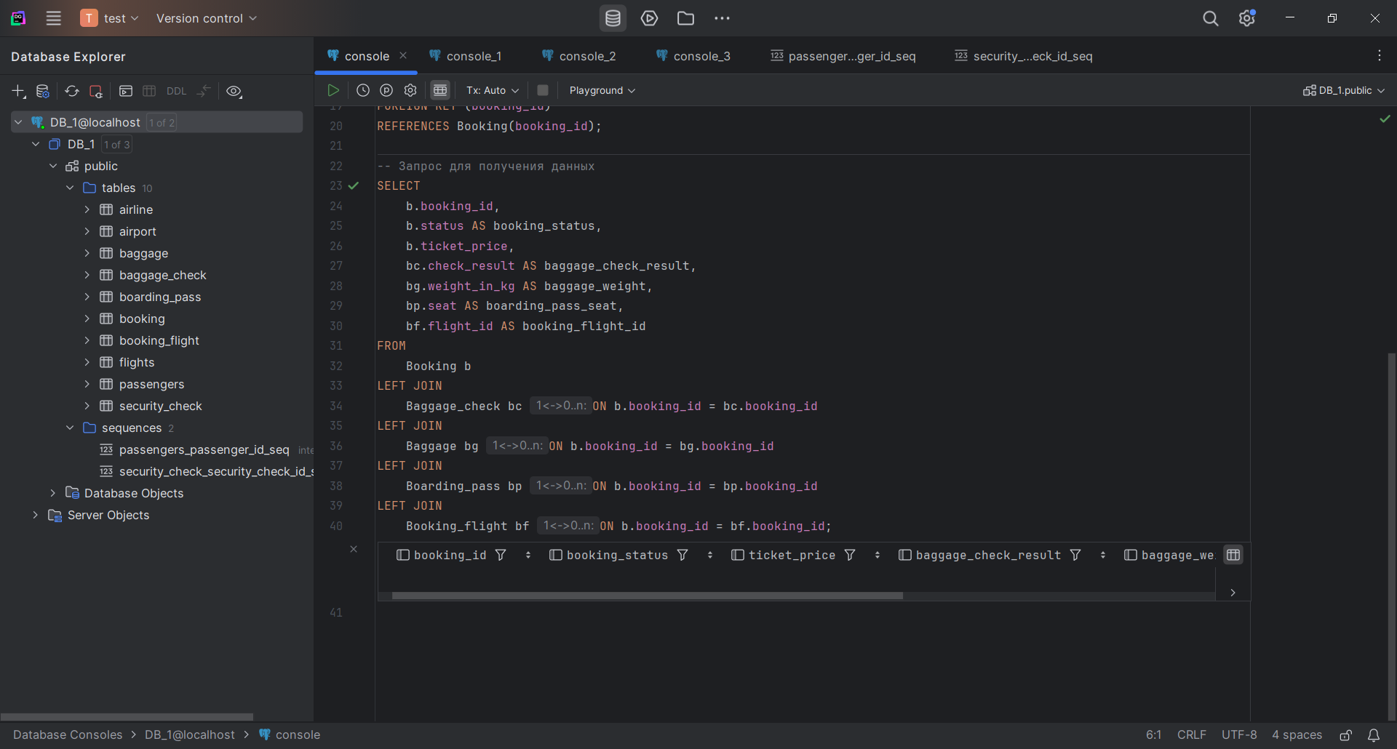

- Flights with Booking_flight by flight_id;

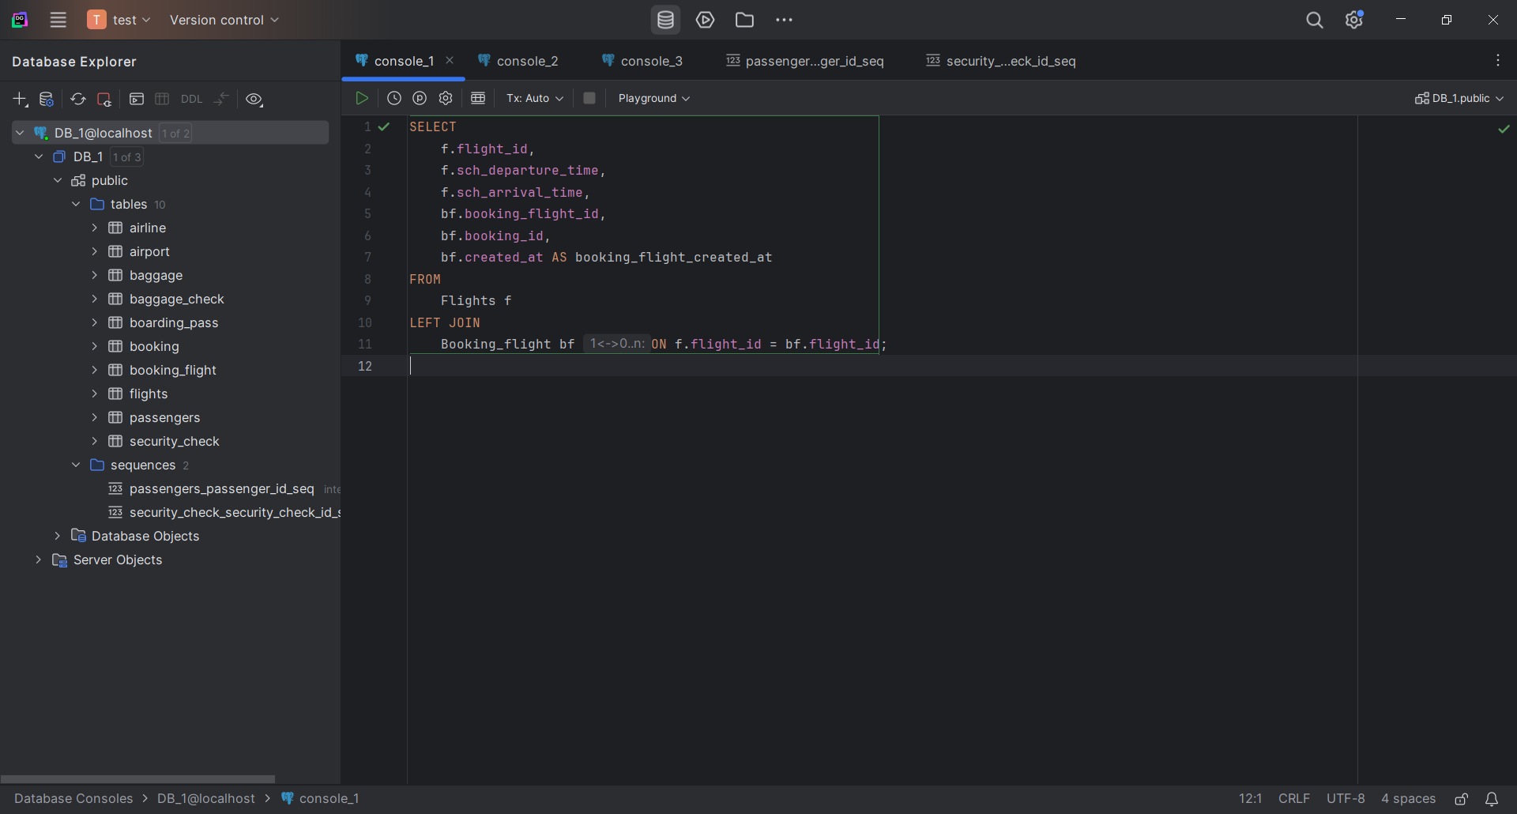

- Airport with Flights by departing_airport_id;

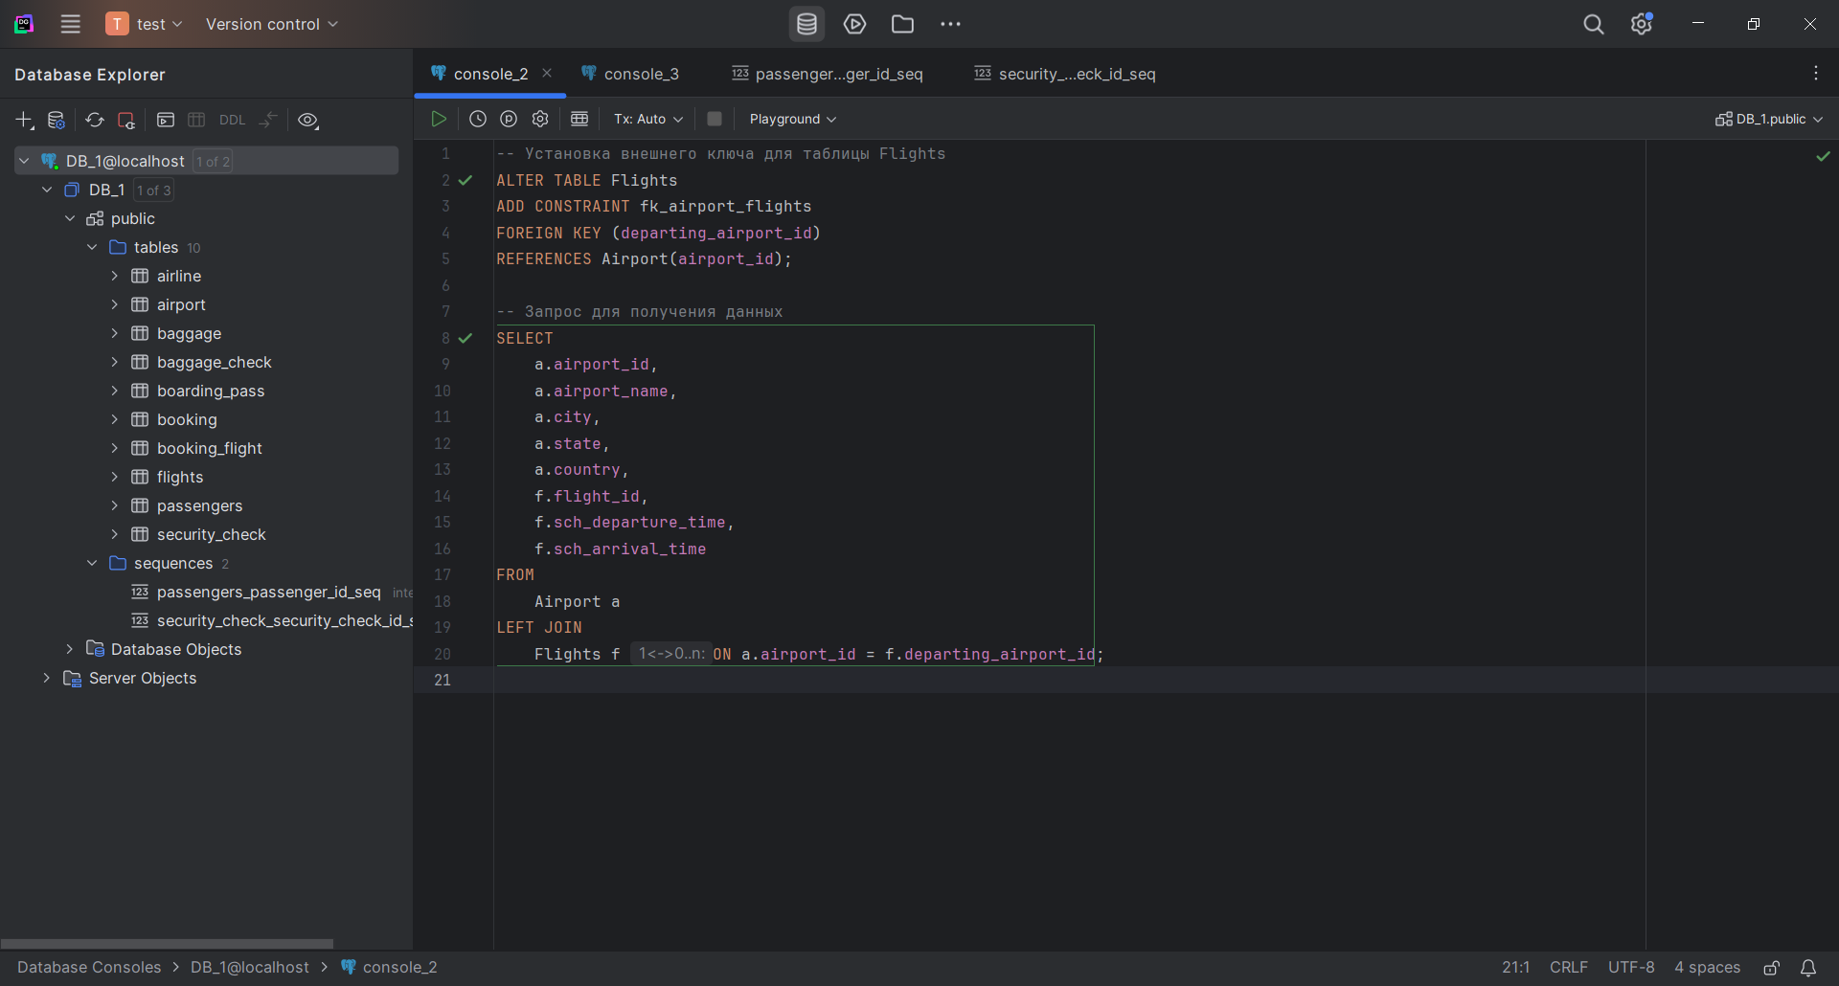

Airport with Flights by arriving_airport_id;

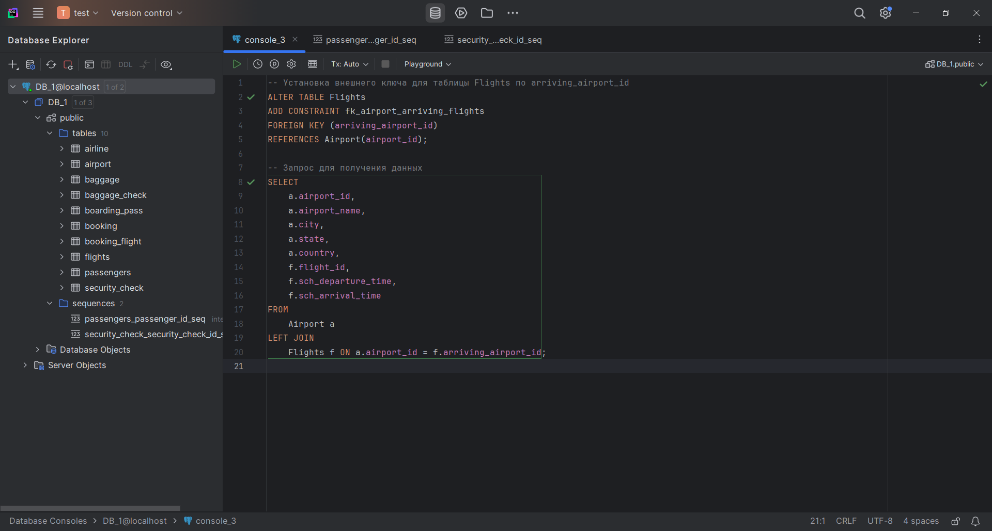

- Airline with Flights by airline_id;

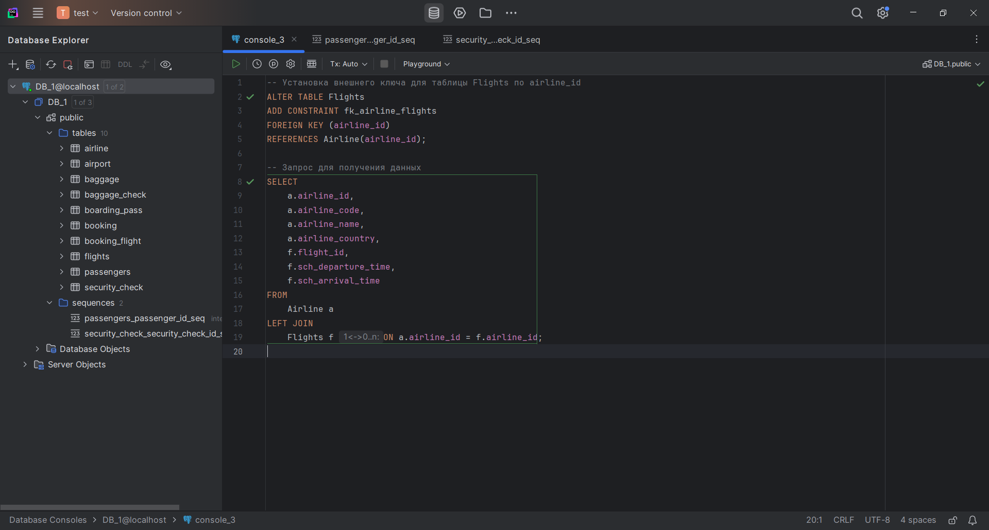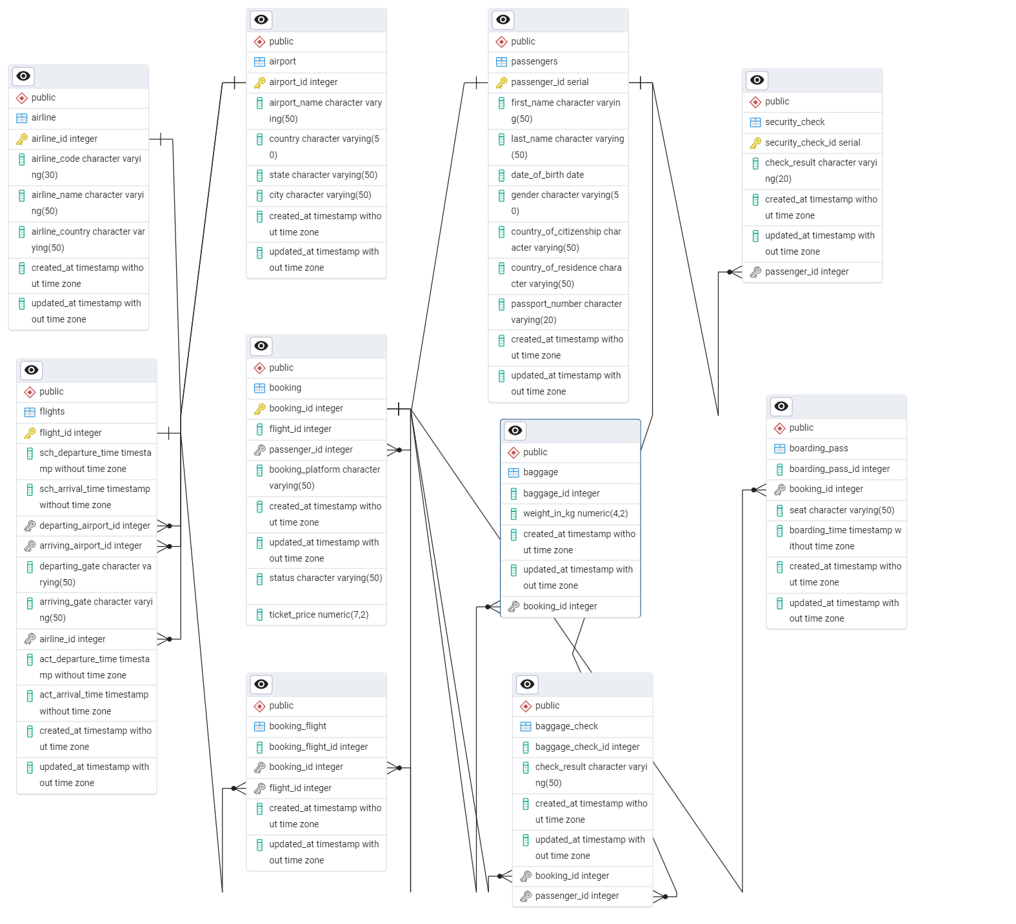

1. Generate and insert 100 random rows in your airport database using mockaroo service (<https://www.mockaroo.com/).(10>%)

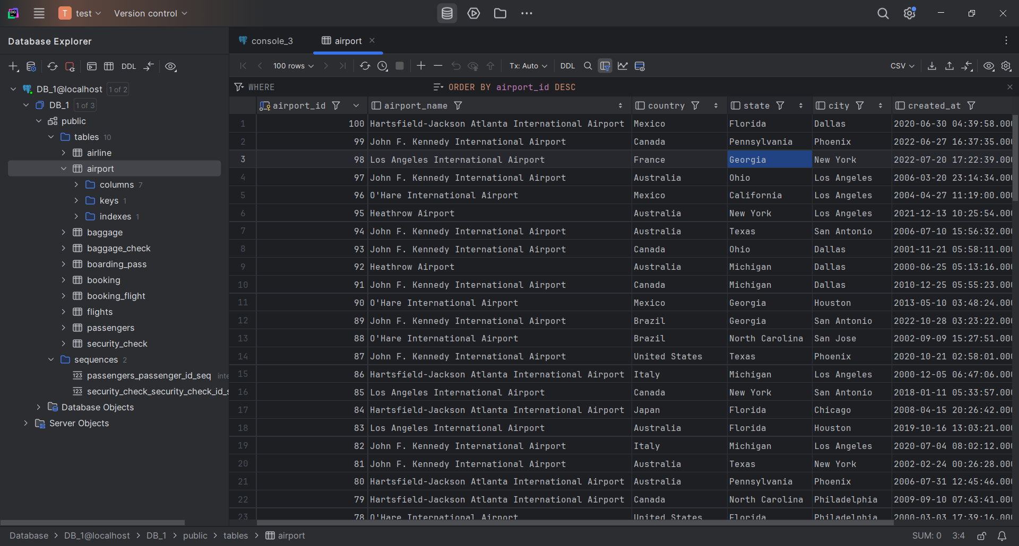

2. Add a new airline named "KazAir" based in "Kazakhstan" to the airline table.(10%)

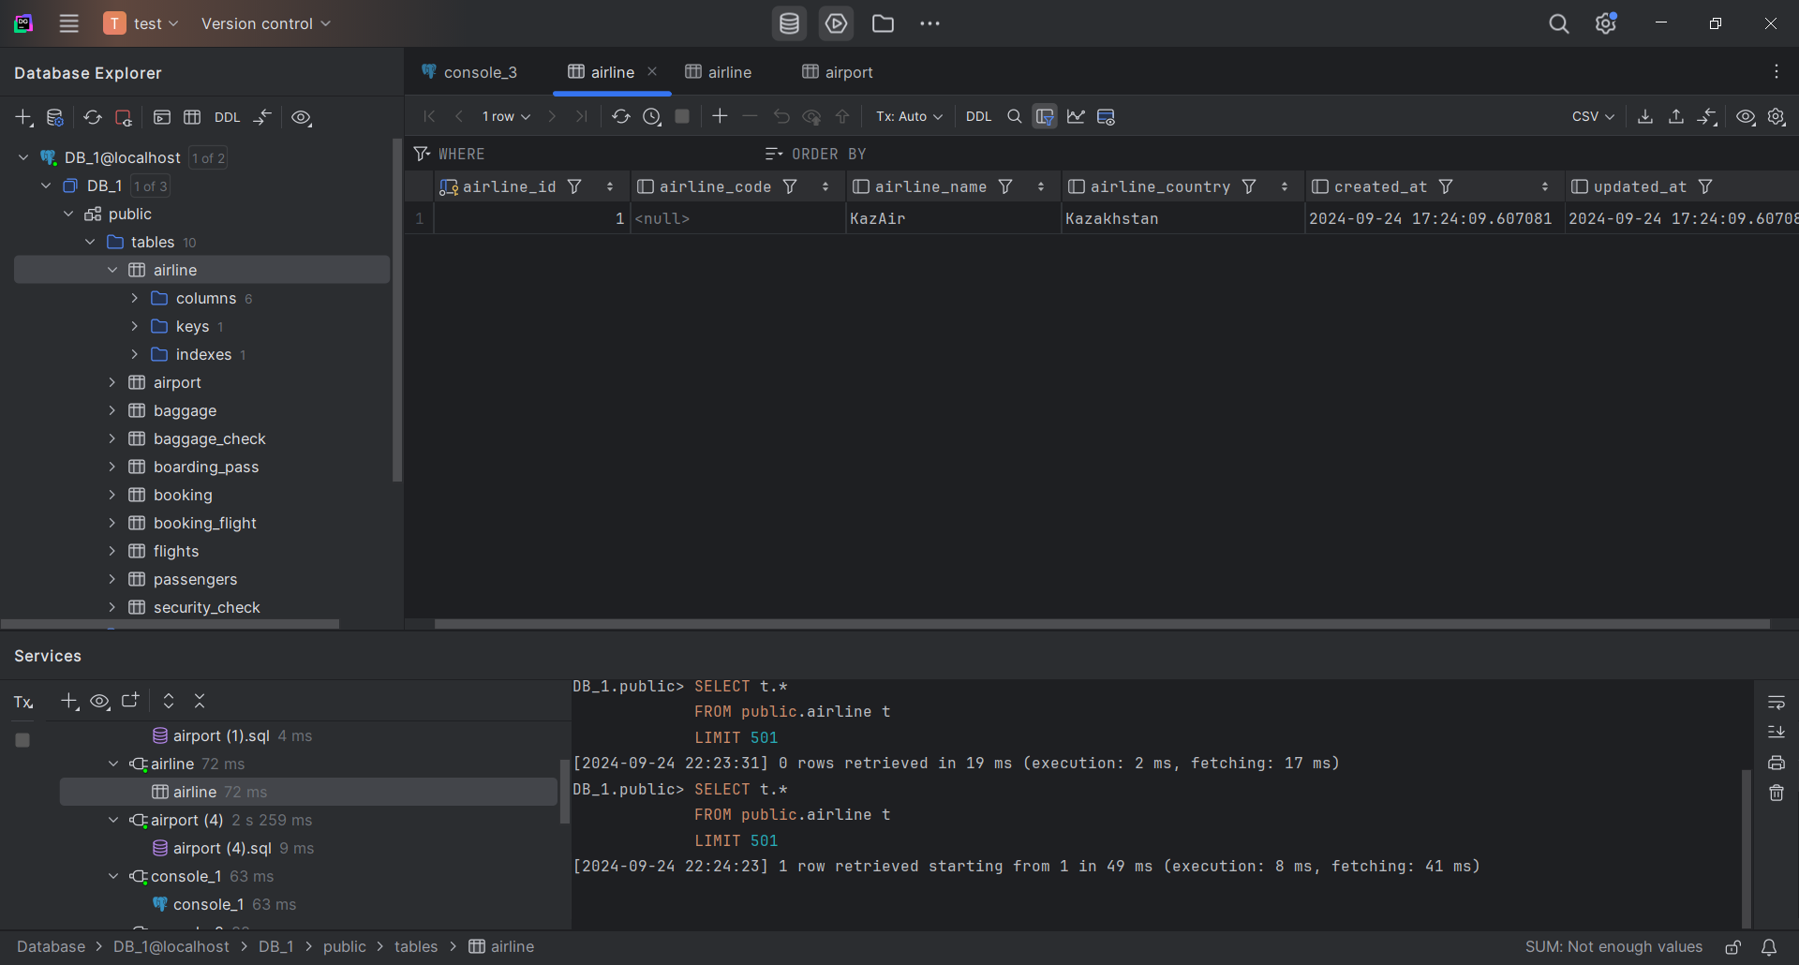

3. Update the airline country "KazAir" to "Turkey".(10%)

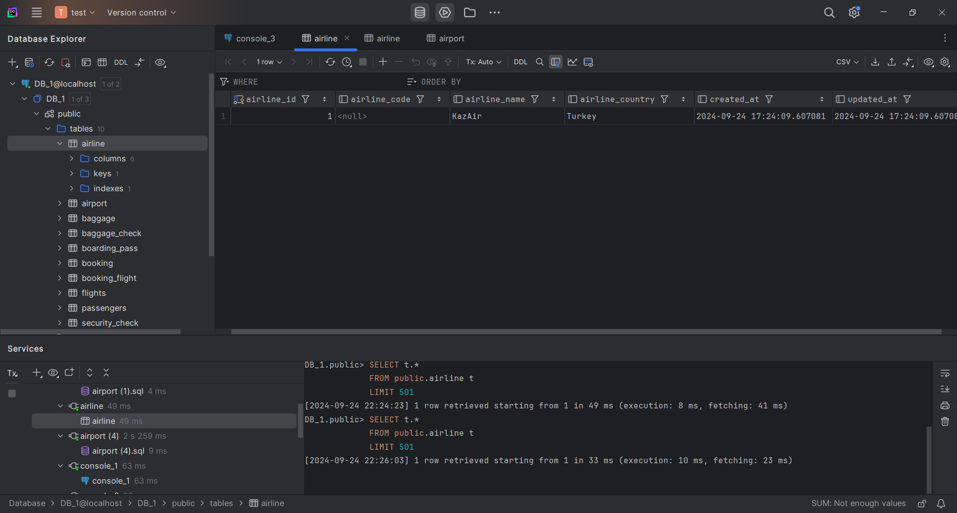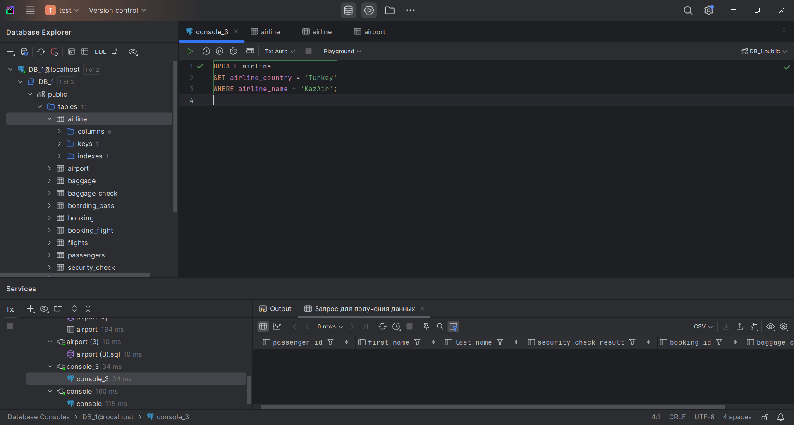

4. Remove the airline named "SIT" from the airline table. (10%)

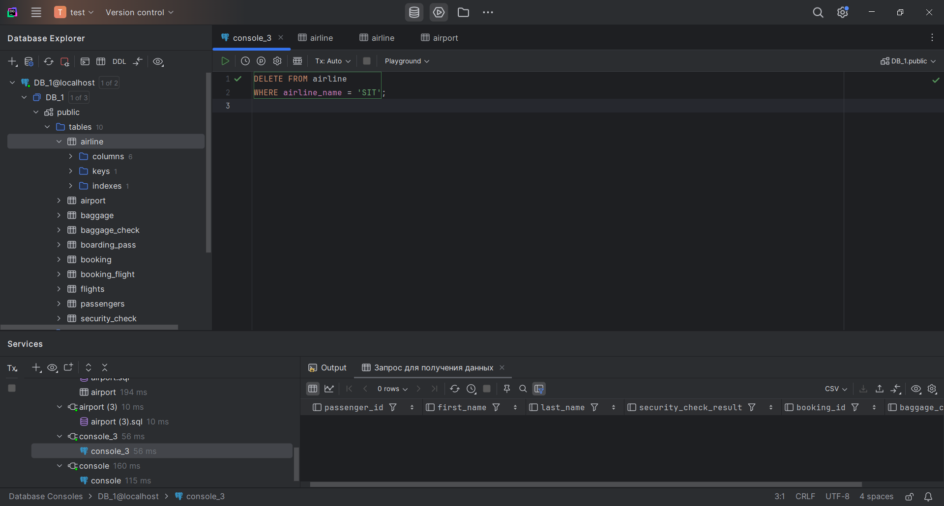

5. Add three airlines at once: "AirEasy" in "France", "FlyHigh" in "Brazil" and "FlyFly" in "Poland". (10%)

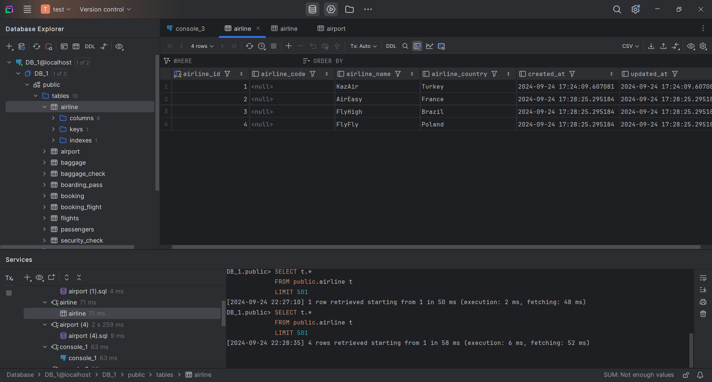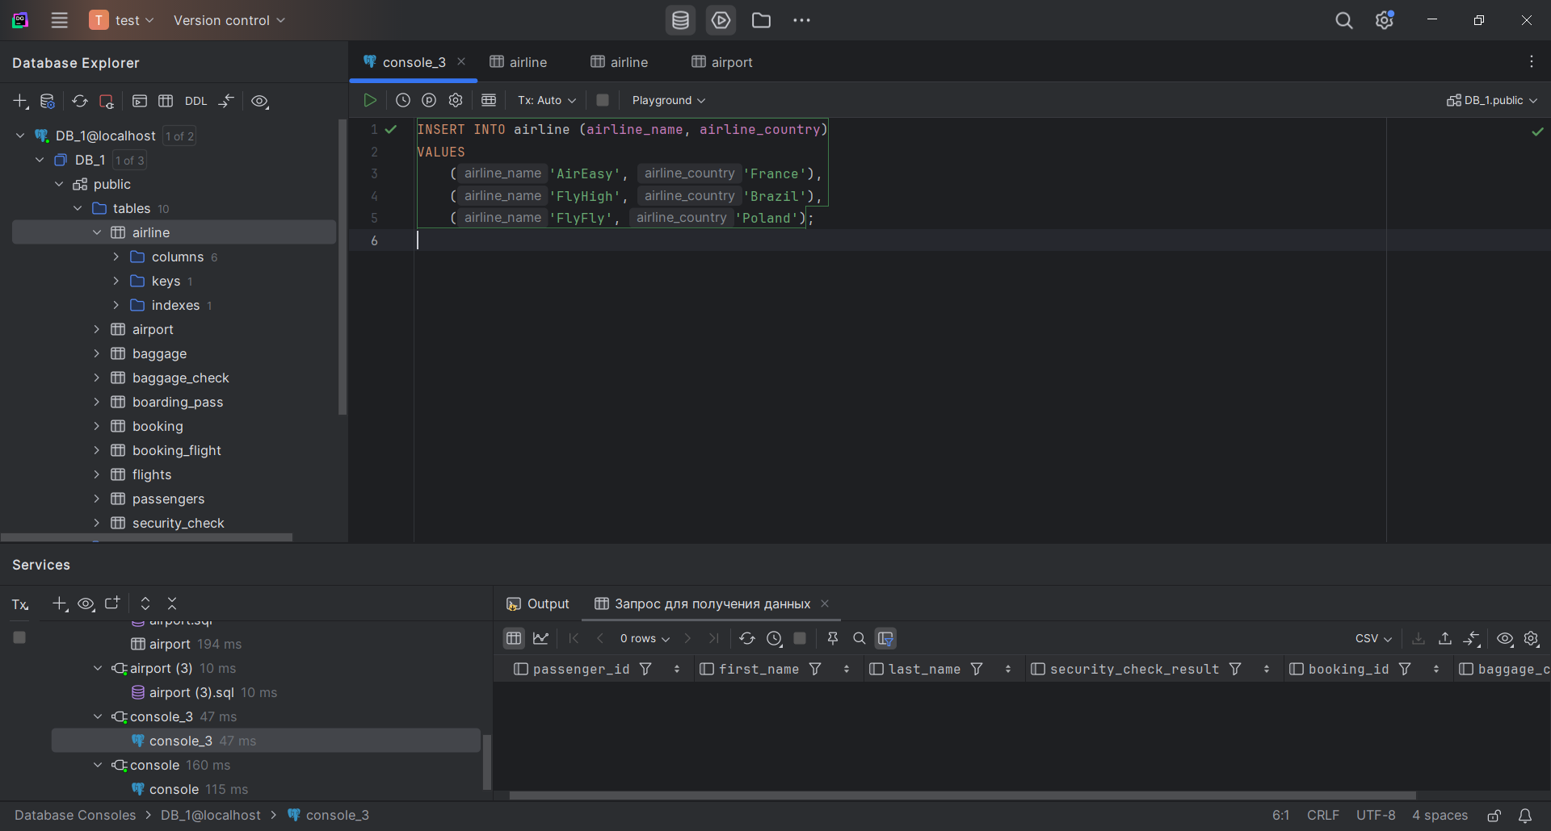

6. Delete all flights whose arrival in 2024 year. (10%)

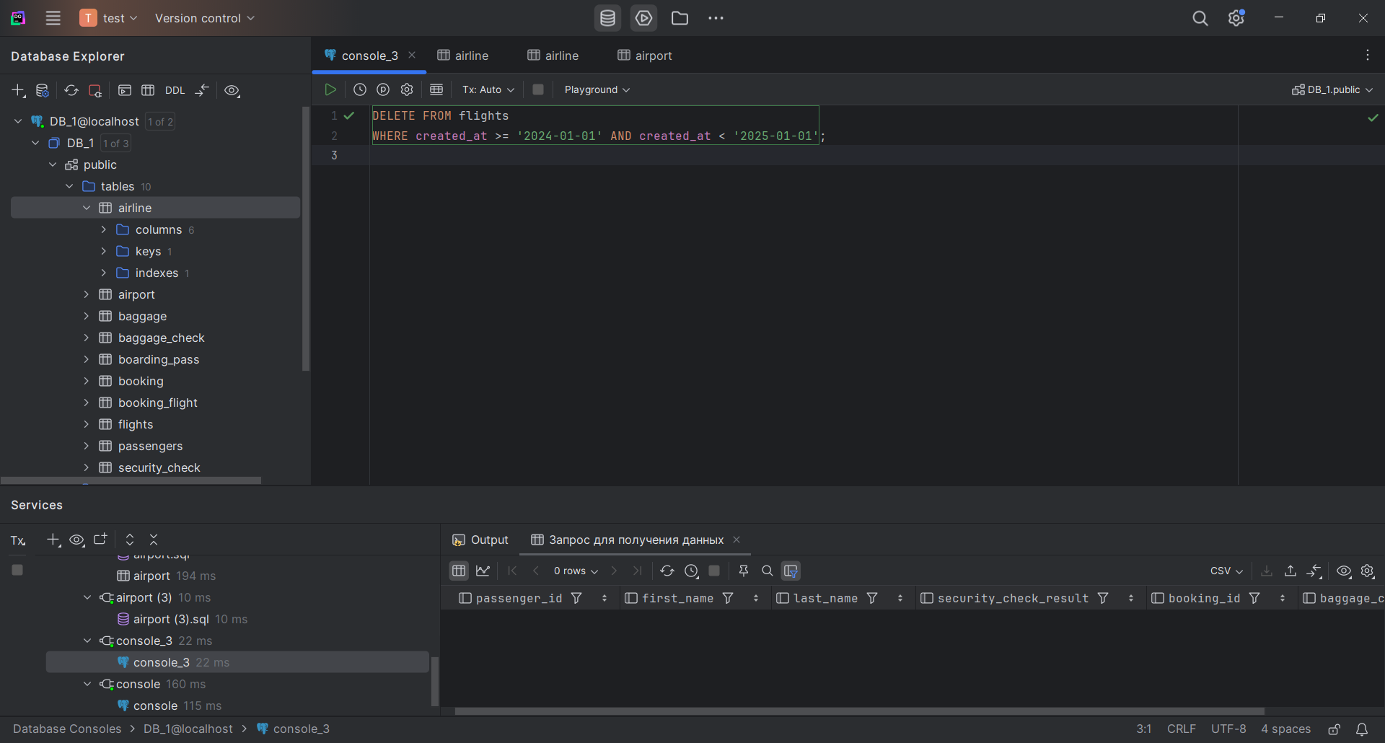

7. Increase the price of all tickets in booking table for flights by 10%.(10%)

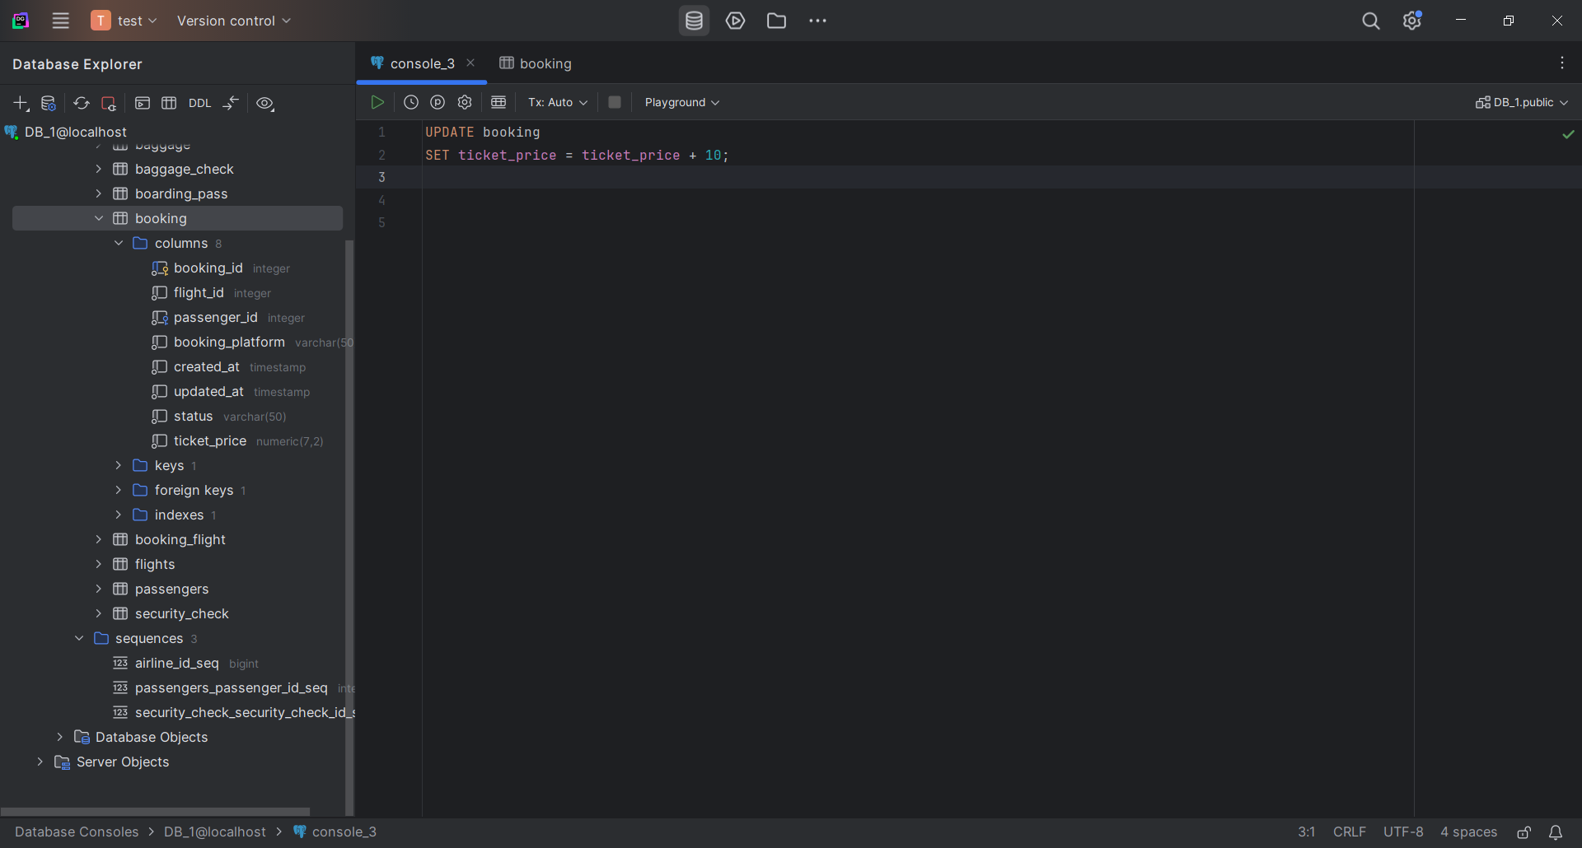

8. Delete all tickets whose price is less than 1000 units. (10%)

